**CURRICULUM VITAE**

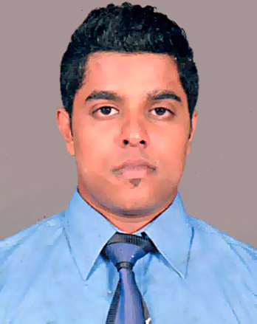

Kaluthotage Dilina Sandaruwan Perera

No. 31/8, Balagala Road, Hendala, Wattala

07777418467 - 0789985709

[dilinadylan93@gmail.com](mailto:dilinadylan93@gmail.com)

***Personal Profile:***

* Gender : Male
* Date Of Birth : 15th April 1993
* Civil Status : Single
* Nationality : Sri Lankan
* Residence : Wattala

***Career Objective:***

To excel among the professionals. When I can utilize my skills with strong commitment and dedication, for the progressive growth of the company.

***Academic Profile:***

**Seventh- day Adventist High School, Kandana**

* **G.C.E Ordinary Level Examination (2009)**

Mathematics A

Science A

Health & Physical Science A

Business & Accounting Studies B

English Language & Lit: C

Sinhala Language & Lit: C

History C

Christianity C

* **G.C.E Advanced Level Examination (2012)**

Economics S

Accounting S

General English S

* Successfully completed HND in Bcs(Hons) Software Engineering at Northshore College.
* Successfully completed a Diploma in Information Technology with

E-commerce at ESoft Metro Campus (International).

* Successfully completed the North shore Competency Development Program.
* Following a Diploma in JAVA at Nottingham College.

***Extra-Curricular Activities***

* Awarded as an active participant of Science Unit
* Awarded as a Mathematics King of Maths competition
* Member of Cricket Tournament of Clergy Fellowship 2008

***Key Skills:***

* Highly developed interpersonal skills with an ability to work with multicultural and multidisciplinary teams.
* Good Analytical and problem solving skills.
* Self confidence and hardworking nature
* Ability to work both independently and as a team player
* Belief in 3P’s concept-
  + - Personality
    - Patience
    - Perspiration

***Language Skills:***

* Good command in English and Sinhala
* Successfully completed two stages of English course at British Council,

Sri Lanka.

* Computer Literacy

***Referees:***

* Mr. S.AM.C. Perera

Import Manager (Walkers Packaging Ltd.)

Tel: 077 3733403

* Mr. D.J. Ranasinghe

Sales Manager (ALCO Logistic PVT Ltd)

Tel: 077 9651235

I certify that above particulars submitted by me are true and correct to the best of my knowledge.

………………………… …………………..

Signature of Employee Date